Exp 3: Spectrum Analysis of Sub-1 GHz, Mid-band & mmWave by Plotting Propagation Loss.

Objective 1 :

Code

clc;
clear;
close all;

d = 0.1:0.1:5;

f = [900 3500 28000];

PL1 = 32.44 + 20*log10(f(1)) + 20*log10(d);

PL2 = 32.44 + 20*log10(f(2)) + 20*log10(d);

PL3 = 32.44 + 20*log10(f(3)) + 20*log10(d);

figure;

subplot(2,1,1);

plot(d, PL1, 'b', 'LineWidth', 2);

hold on;

plot(d, PL2, 'r', 'LineWidth', 2);

plot(d, PL3, 'k', 'LineWidth', 2);

title('Propagation Loss vs Distance');

xlabel('Distance (km)');

ylabel('Loss (dB)');

grid on;

subplot(2,1,2);

Freq = [900 3500 28000];

Loss = [PL1(10) PL2(10) PL3(10)];

plot(Freq, Loss, '-o', 'LineWidth', 2);

title('Propagation Loss vs Frequency');

xlabel('Frequency (MHz)');

ylabel('Loss (dB)');

grid on;

Output

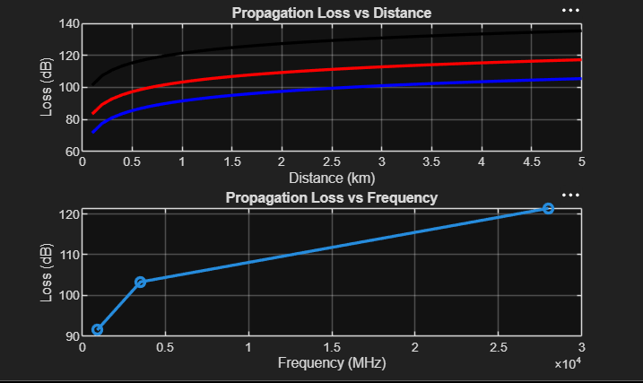

Objective 2 :

Code

clc;
clear;
close all;

d = 2;

f = [900 3500 28000];

PL = 32.44 + 20*log10(f) + 20*log10(d);

figure;

subplot(2,1,1);

plot(f, PL, '-o', 'LineWidth', 2);

title('Propagation Loss vs Operating Frequency');

xlabel('Frequency (MHz)');

ylabel('Propagation Loss (dB)');

grid on;

subplot(2,1,2);

bar(PL);

title('Comparison of Propagation Loss Across Bands');

xlabel('Frequency Bands (Index: 1=Sub-1GHz, 2=Mid-band, 3=mmWave)');

ylabel('Propagation Loss (dB)');

xticklabels({'Sub-1GHz','Mid-band','mmWave'});

grid on;

Output

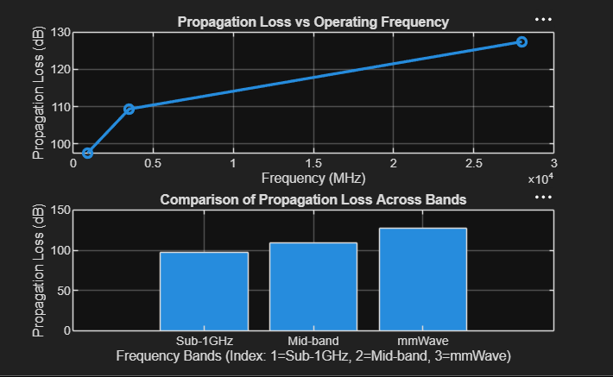

Objective 3 :
Code

clc;
clear;
close all;

f = [900 3500 28000];

d = 2;

PL = 32.44 + 20*log10(f) + 20*log10(d);

figure;

subplot(2,1,1);

plot(f, PL, '-o', 'LineWidth', 2);

title('Propagation Loss vs Operating Frequency');

xlabel('Frequency (MHz)');

ylabel('Propagation Loss (dB)');

grid on;

subplot(2,1,2);

plot(1:3, PL, '-s', 'LineWidth', 2);

title('Band-wise Propagation Loss Comparison');

xlabel('Band Index (1 = Sub-1GHz, 2 = Mid-band, 3 = mmWave)');

ylabel('Propagation Loss (dB)');

grid on;

Output

